Project Design Phase-II

Data Flow Diagram & User Stories

|  |  |
| --- | --- |
| Date | 19 September 2022 |
| Team ID | PNT2022TMID48980 |
| Project Name | IoT Based Safety Gadget for Child Safety Monitoring & Notification |
| Maximum Marks | 4 Marks |

**Data Flow Diagrams:**

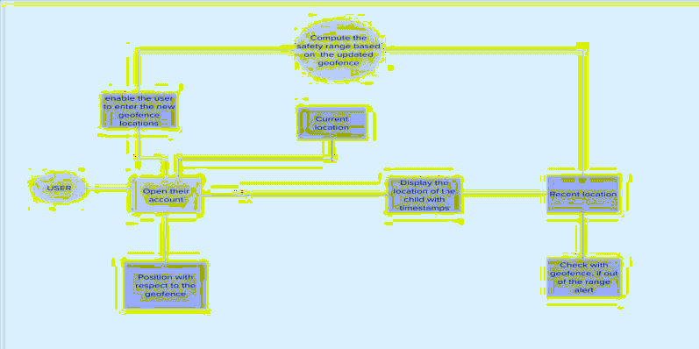

**User Stories**

|  |  |  |  |  |  |  |
| --- | --- | --- | --- | --- | --- | --- |
| **User Type** | **Functional Requirement**  **(Epic)** | **User Story Number** | **User Story / Task** | **Acceptance criteria** | **Priority** | **Release** |
| Customer (Mobile user) | Registration | USN-1 | As a user, I can register for the application by entering my email, password, and confirming my password. | I can access my account / dashboard | High | Sprint-1 |
|  |  | USN-2 | As a user, I will receive confirmation email once I have registered for the application | I can receive confirmation email & click confirm | High | Sprint-1 |
|  |  | USN-3 | As a user, I can register for the application through Google Account | I can register & access the  dashboard with Google Login | Low | Sprint-2 |
|  | Login | USN-4 | As a user, I can log into the application by entering email & password |  | High | Sprint-1 |
|  | Dashboard |  |  |  |  |  |
| Customer Care Executive | Login |  | As I enter, I can view the working of the application and scan for any glitches and  monitor the operation andcheck if all the users are authorized. | I can login only with my provided credentials. | Medium | Sprint-3 |
| Administrator | Login |  | Maintaining and making sure the database containing the locations are secure and accurate and updated constantly. | I can login only with my provided credentials. | High | Sprint-3 |